YESBANK PROD MANUAL TESTING OF ALL CORPORATE ACTIONS.

DIRECT PLACEMENT:

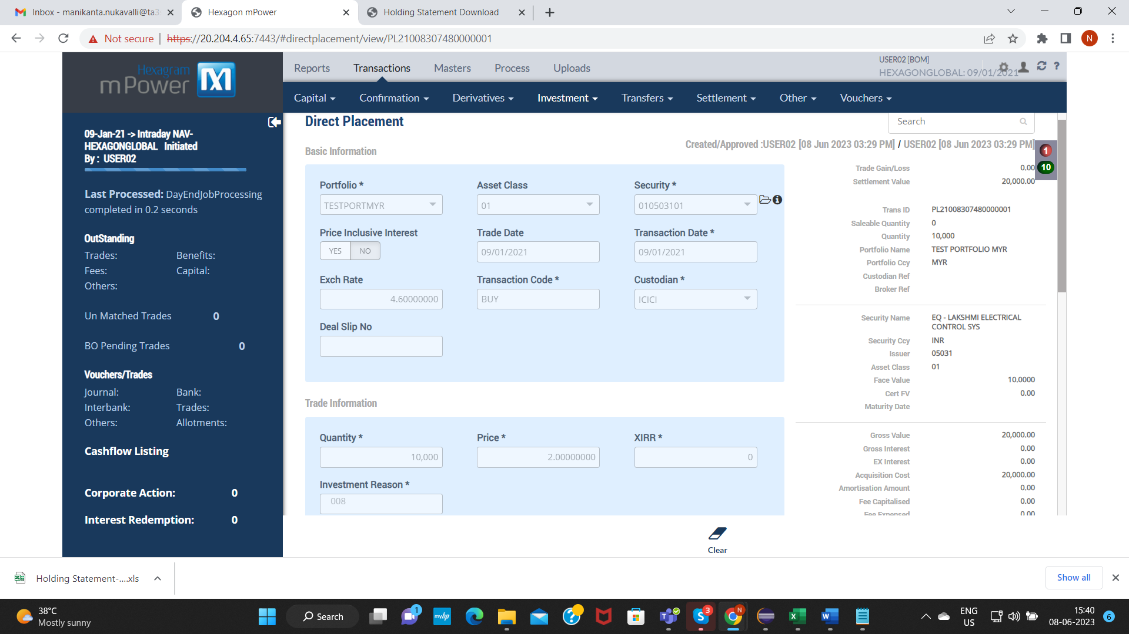

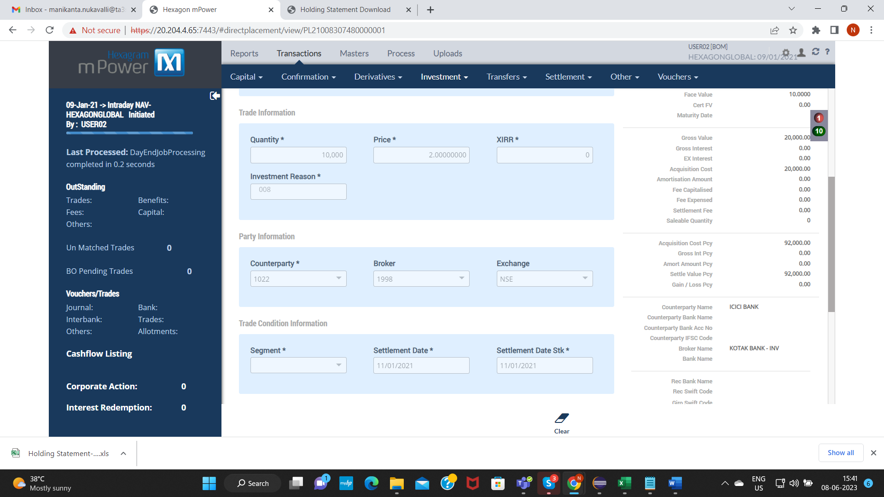

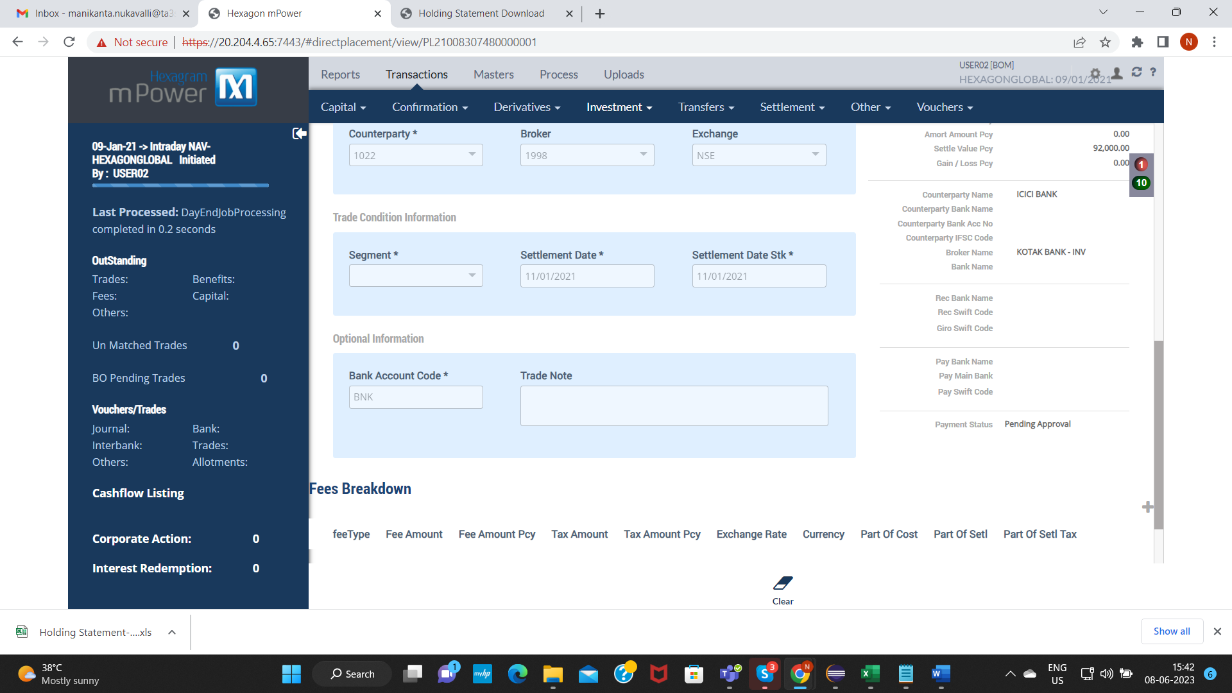

Face value of Security – 010503101

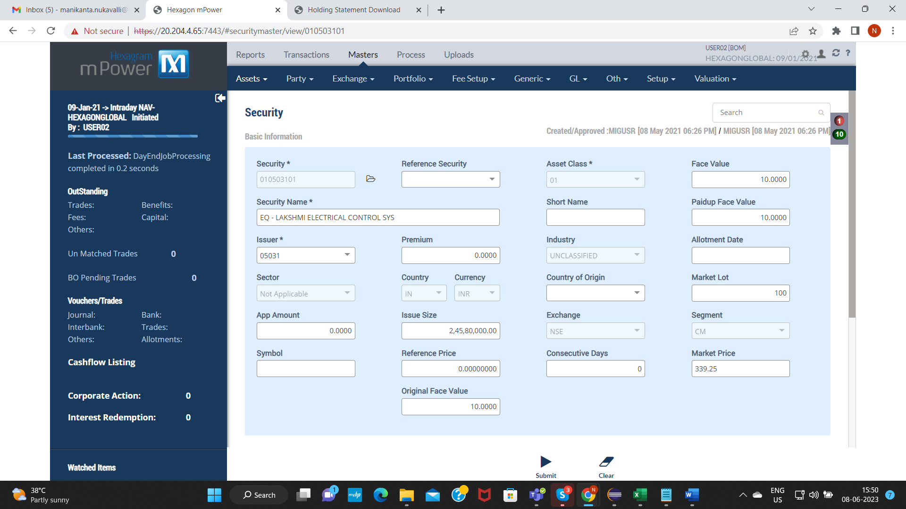

DIVIDEND MODULE:

COROPORATE ACTION FORM: BF210000456

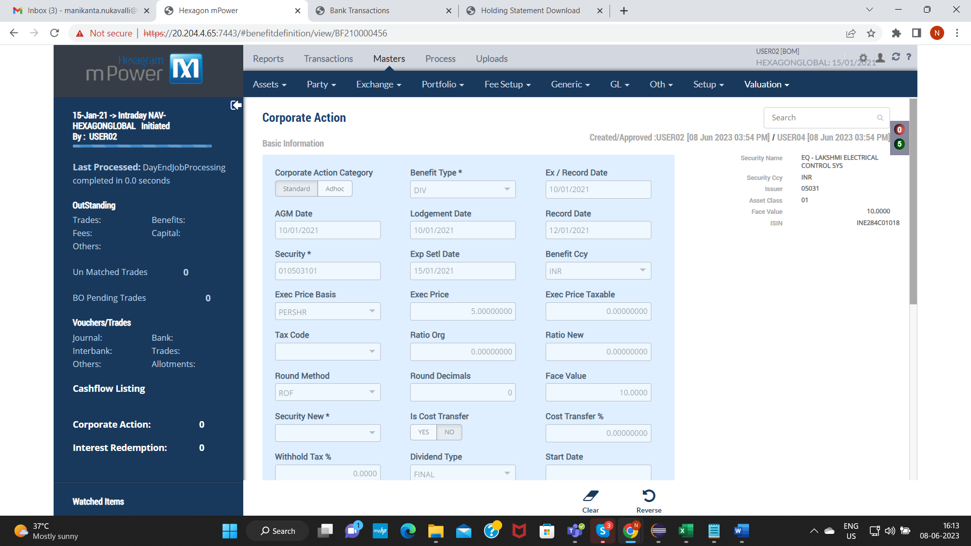

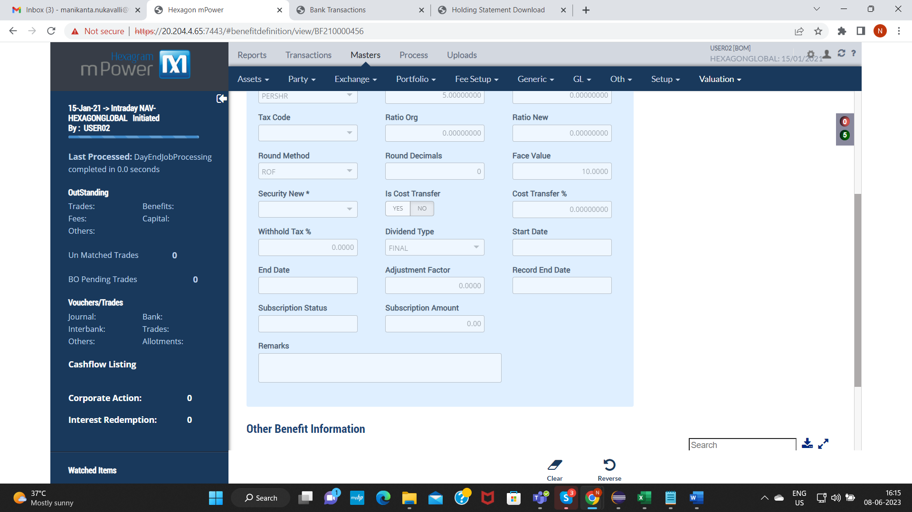

Settlement Transaction: BA21008307480000001

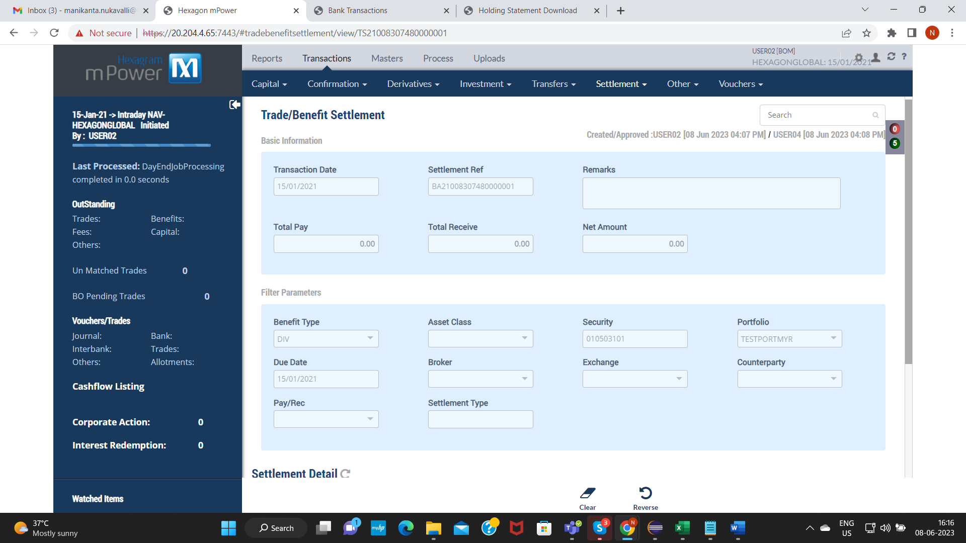

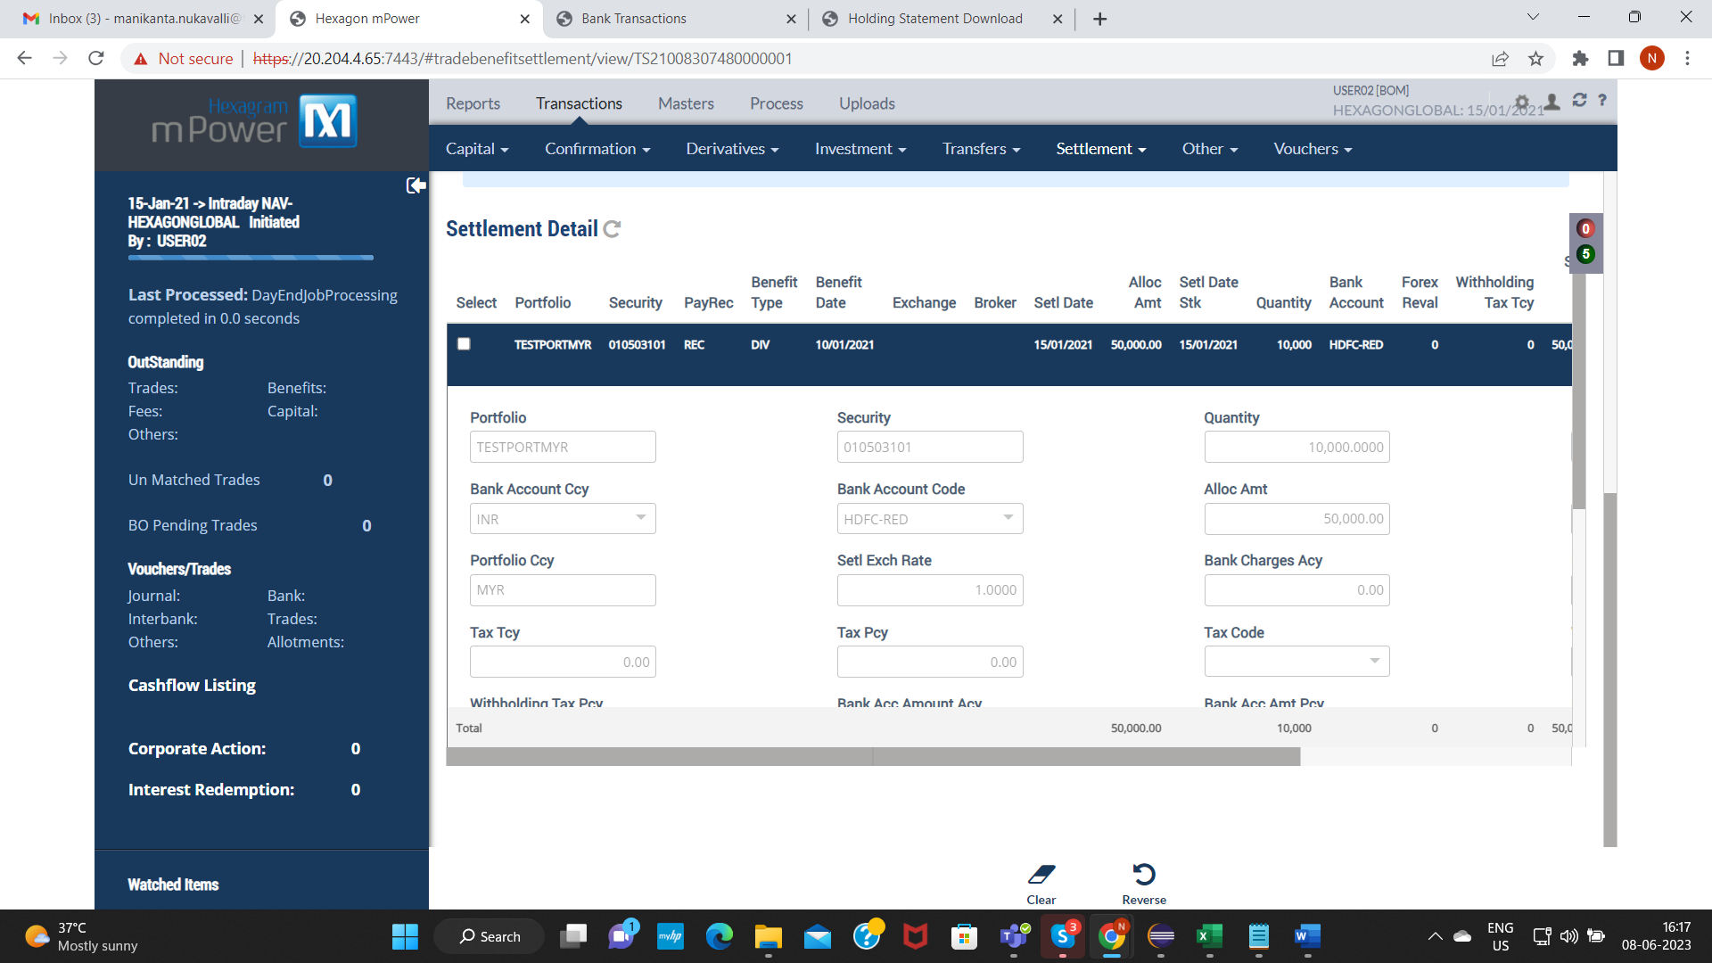

ACCOUINTING ENQUIRES: FOR SETTLEMENT DATE – 15-01-2021

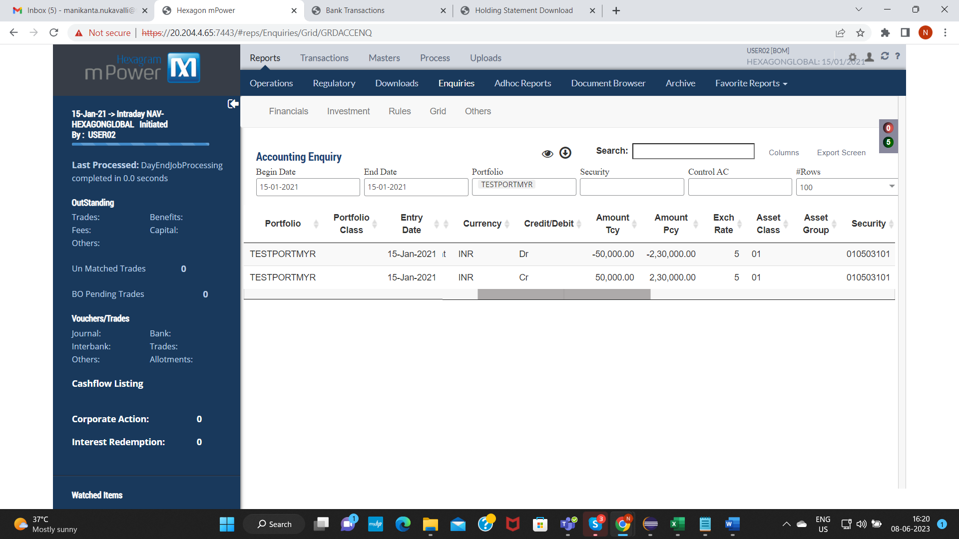

BANK TRANSACTION REPORT: FOR SETTLEMENT DATE 15-01-2021

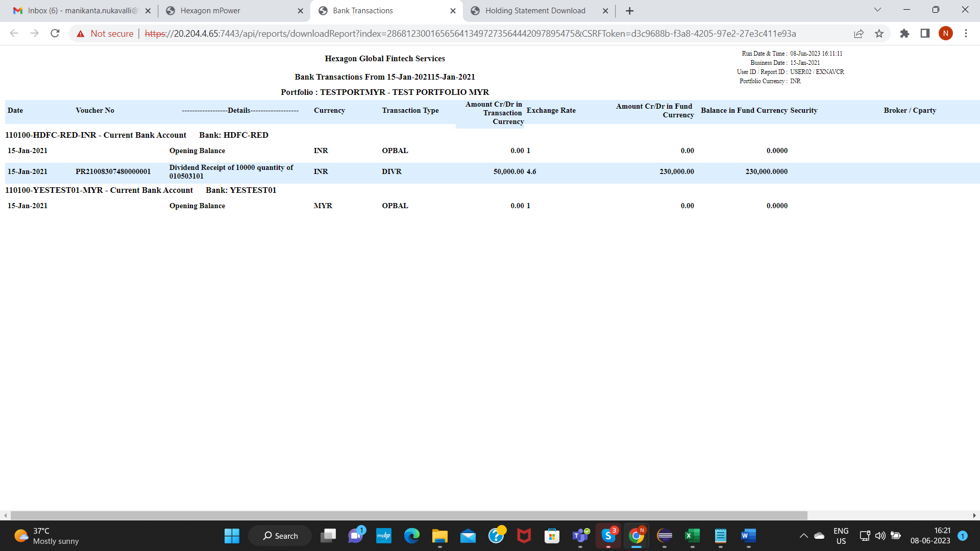

VERIFYING FACEVALUE ON SECUIRTY SCREEN AFTER PERFORMING CORPORATE ACTION: 010503101

